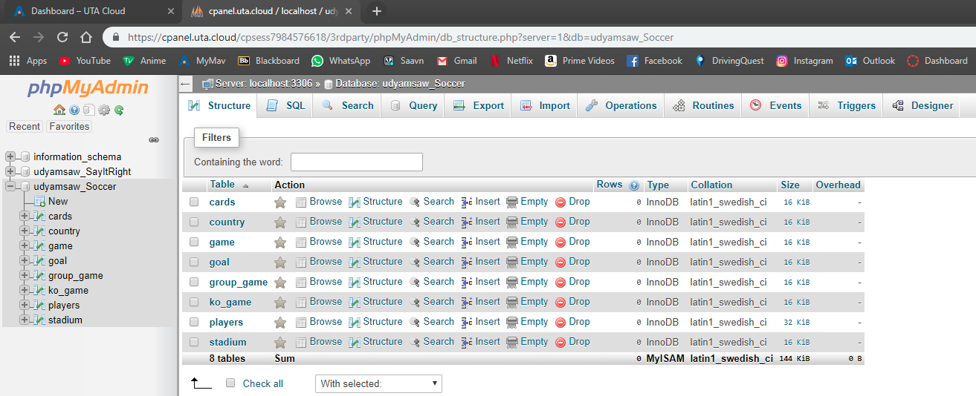

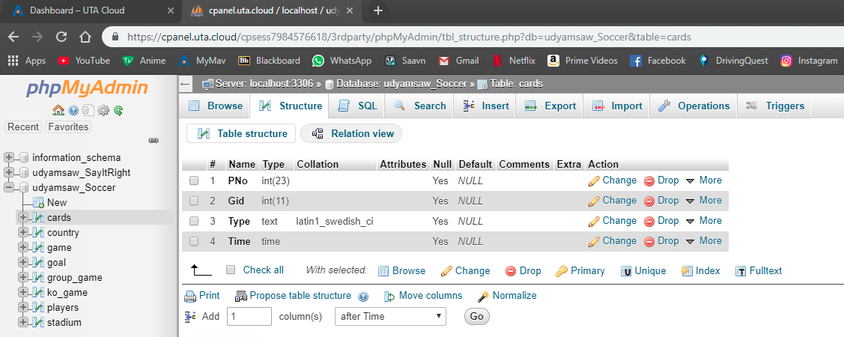

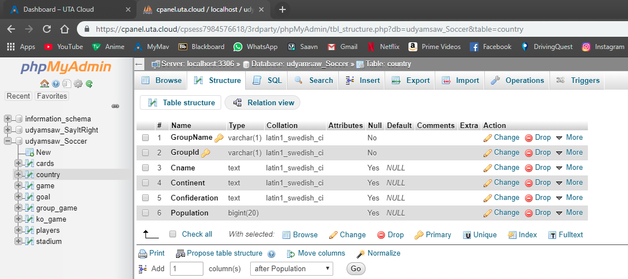

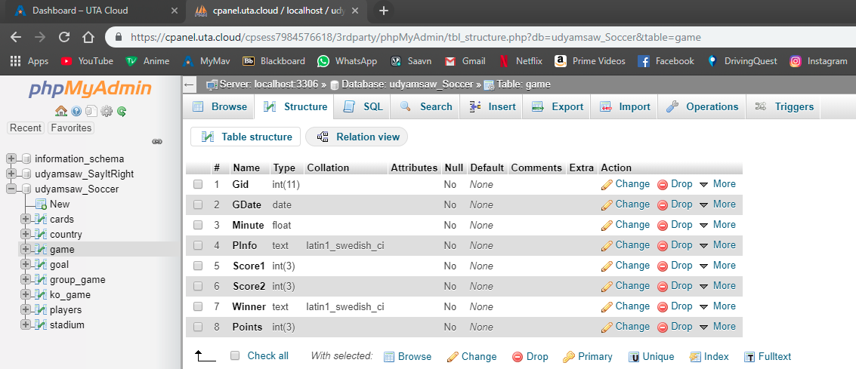

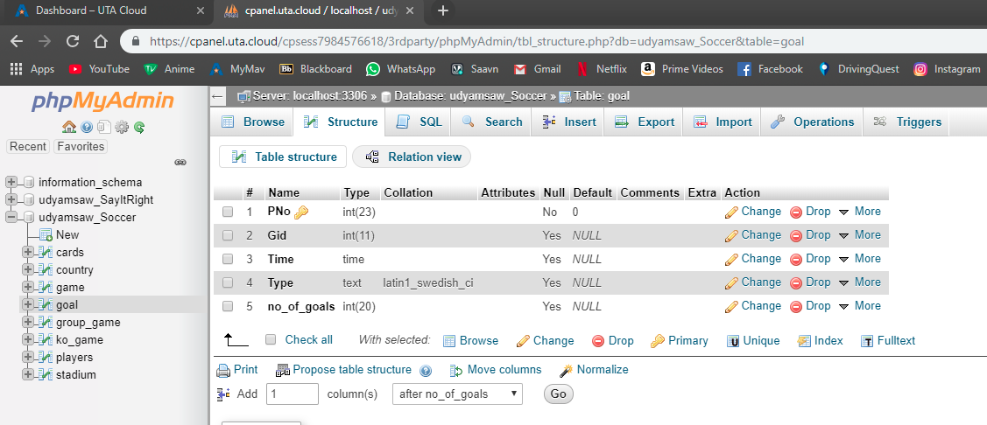

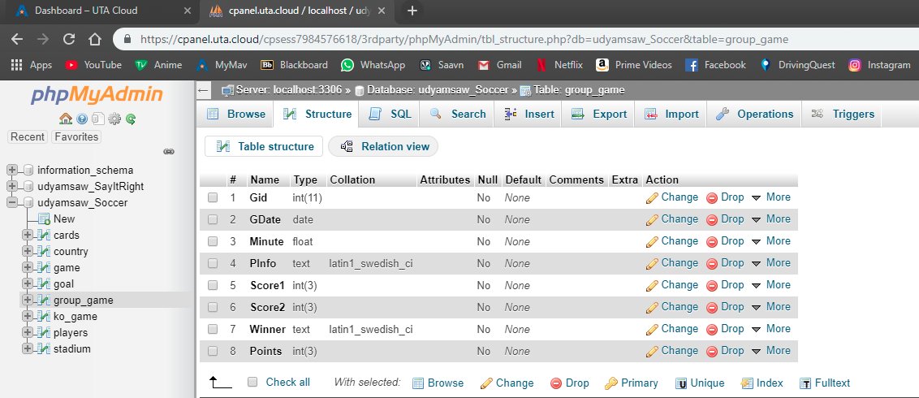

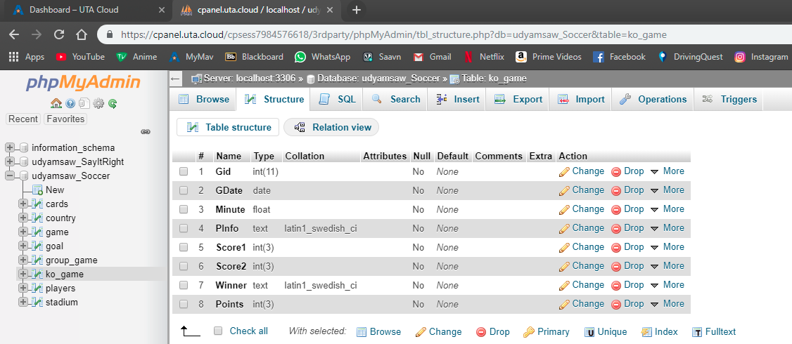

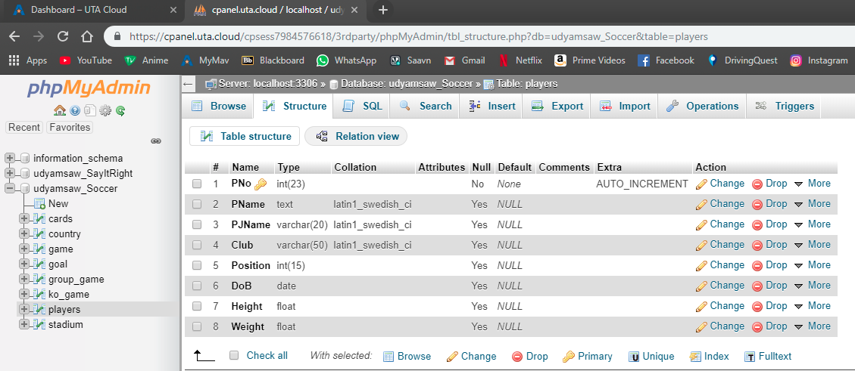

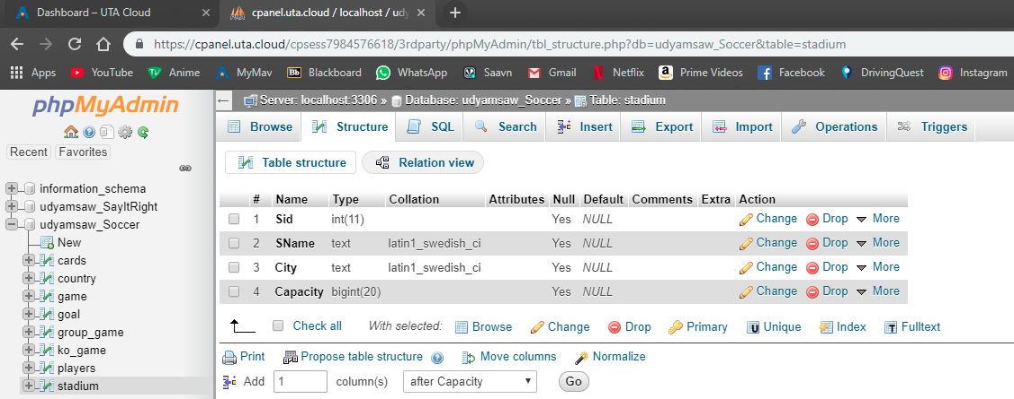

Database: `udyamsaw_Soccer`

CREATE TABLE `cards` (

`PNo` int(23) DEFAULT NULL,

`Gid` int(11) DEFAULT NULL,

`Type` text,

`Time` time DEFAULT NULL

) ENGINE=InnoDB DEFAULT CHARSET=latin1;

CREATE TABLE `goal` (

`PNo` int(23) NOT NULL DEFAULT '0',

`Gid` int(11) DEFAULT NULL,

`Time` time DEFAULT NULL,

`Type` text,

`no_of_goals` int(20) DEFAULT NULL

) ENGINE=InnoDB DEFAULT CHARSET=latin1;

CREATE TABLE `group_game` (

`Gid` int(11) NOT NULL,

`GDate` date NOT NULL,

`Minute` float NOT NULL,

`PInfo` text NOT NULL,

`Score1` int(3) NOT NULL,

`Score2` int(3) NOT NULL,

`Winner` text NOT NULL,

`Points` int(3) NOT NULL

) ENGINE=InnoDB DEFAULT CHARSET=latin1;

CREATE TABLE `ko_game` (

`Gid` int(11) NOT NULL,

`GDate` date NOT NULL,

`Minute` float NOT NULL,

`PInfo` text NOT NULL,

`Score1` int(3) NOT NULL,

`Score2` int(3) NOT NULL,

`Winner` text NOT NULL,

`Points` int(3) NOT NULL

) ENGINE=InnoDB DEFAULT CHARSET=latin1;

CREATE TABLE `game` (

`Gid` int(11) NOT NULL,

`GDate` date NOT NULL,

`Minute` float NOT NULL,

`PInfo` text NOT NULL,

`Score1` int(3) NOT NULL,

`Score2` int(3) NOT NULL,

`Winner` text NOT NULL,

`Points` int(3) NOT NULL

) ENGINE=InnoDB DEFAULT CHARSET=latin1;

CREATE TABLE `country` (

`GroupName` varchar(1) NOT NULL DEFAULT '',

`GroupId` varchar(1) NOT NULL DEFAULT '',

`Cname` text,

`Continent` text,

`Confideration` text,

`Population` bigint(20) DEFAULT NULL

) ENGINE=InnoDB DEFAULT CHARSET=latin1;

CREATE TABLE `player` (

`PNo` int(23) NOT NULL,

`PName` text,

`PJName` varchar(20) DEFAULT NULL,

`Club` varchar(50) DEFAULT NULL,

`Position` int(15) DEFAULT NULL,

`DoB` date DEFAULT NULL,

`Height` float DEFAULT NULL,

`Weight` float DEFAULT NULL

) ENGINE=InnoDB DEFAULT CHARSET=latin1;

CREATE TABLE `stadium` (

`Sid` int(11) DEFAULT NULL,

`SName` text,

`City` text,

`Capacity` bigint(20) DEFAULT NULL

) ENGINE=InnoDB DEFAULT CHARSET=latin1;

Select * from cards

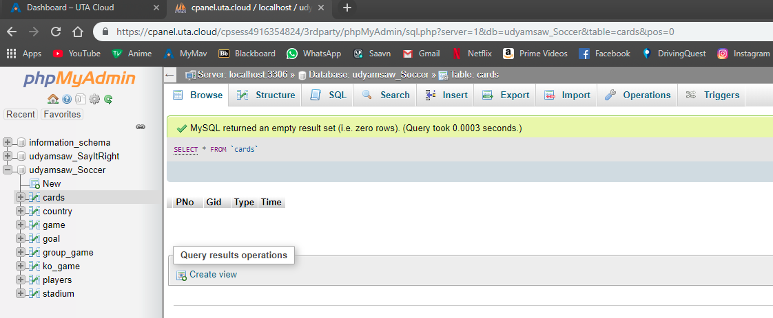

Select * from country

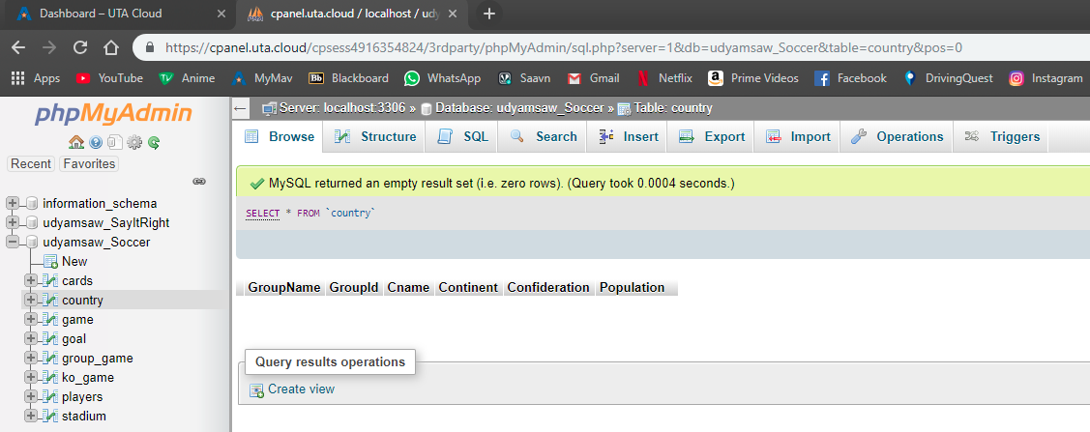

Select * from game

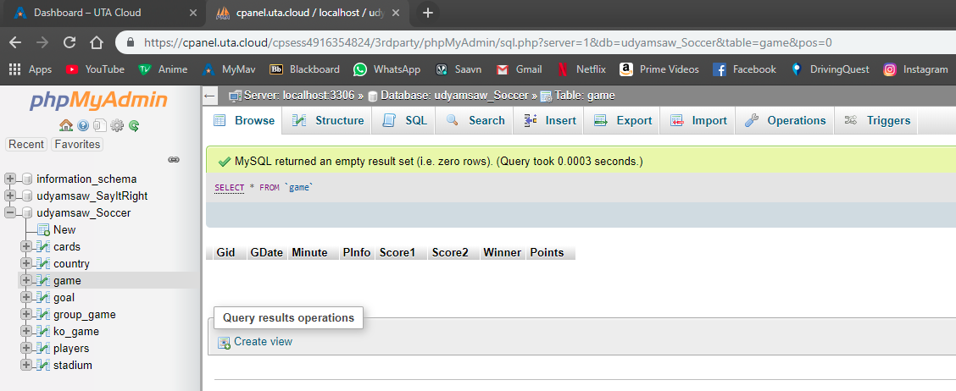

Select * from goal

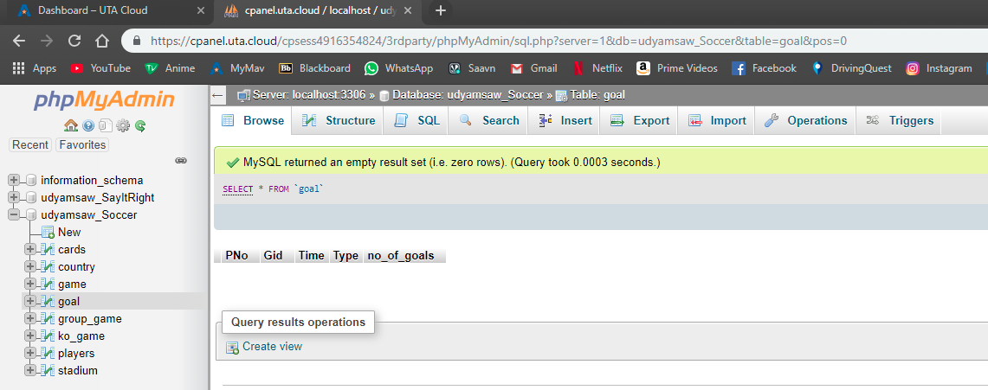

Select * from group_game

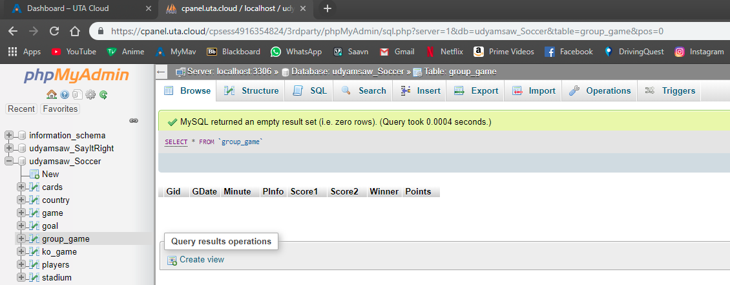

Select * from ko_game

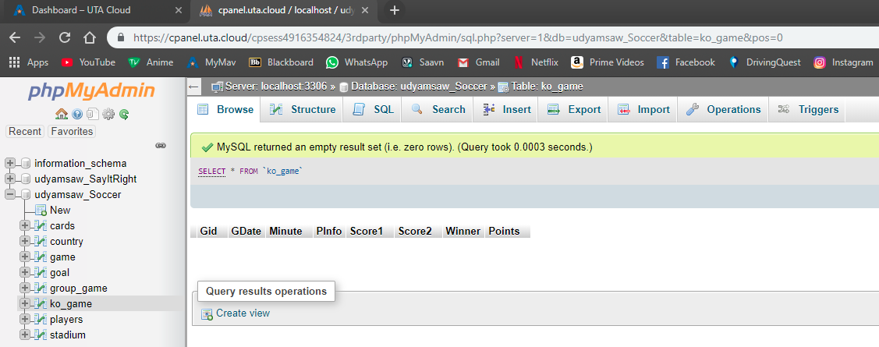

Select * from players

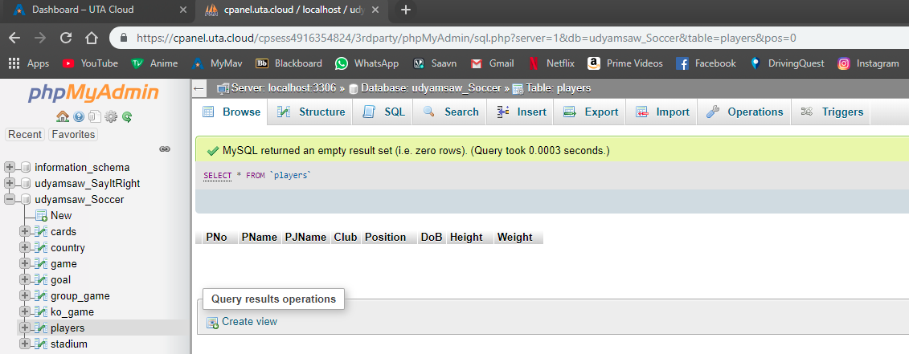

Select * from stadium

